**Power Bi Tutorial**

# Step 1:

# To import the dataset/file into Power BI, we click on the Get Data icon on the ribbon of Home tab.

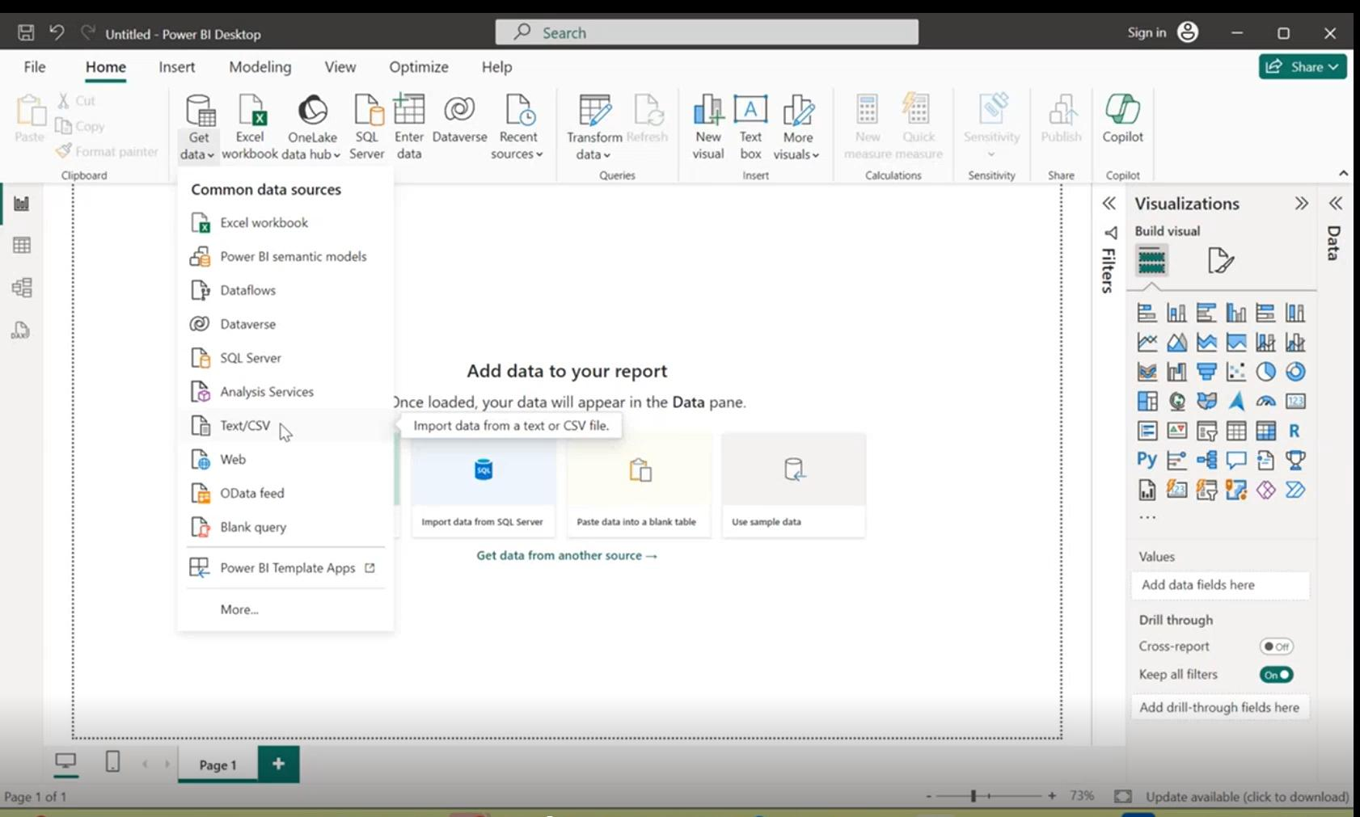

**Once we select this, we go ahead and select the CSV option under the file subheading.Then browse the file and select the necessary CSV file.**

**Step 2:**

**Loaded CSV file will open as follows:**

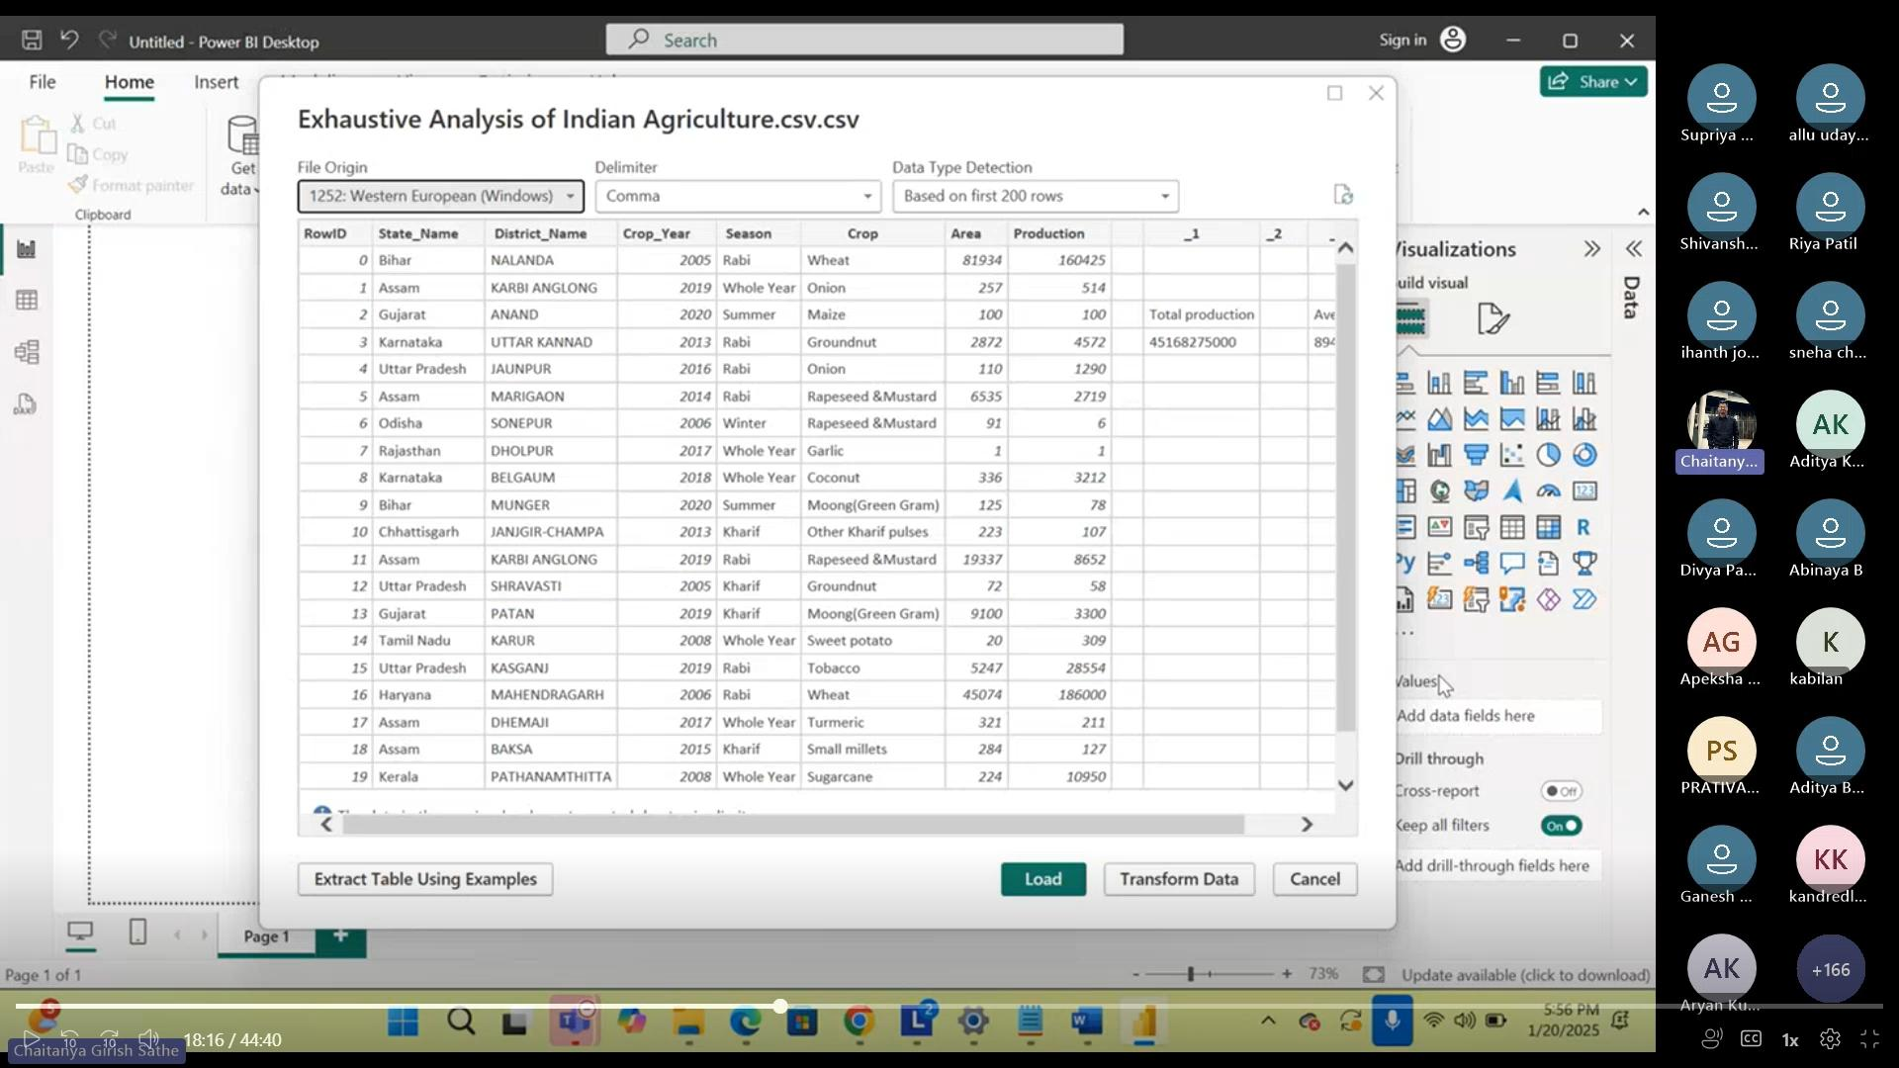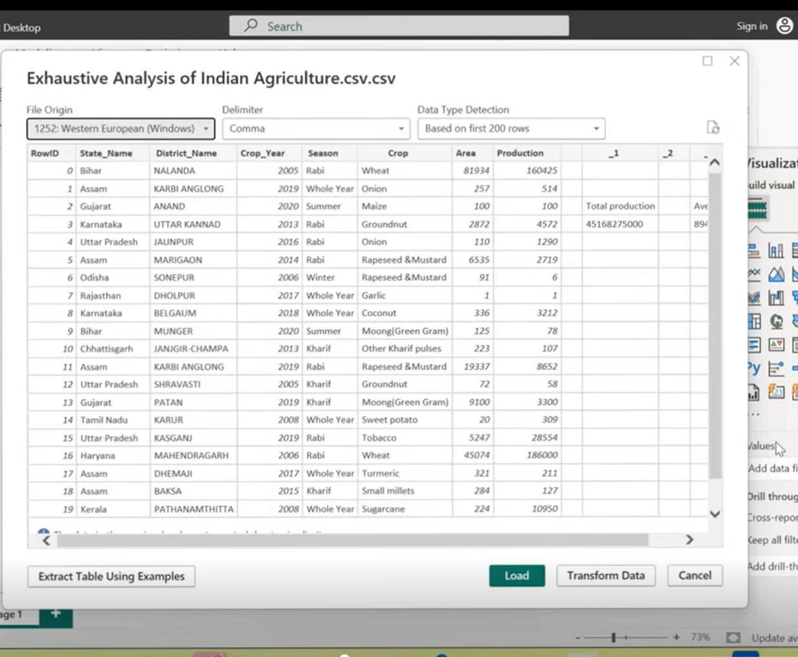

**Here there are two options:**

**1)Load : Load the data into Power BI without making any changes to it.**

**2)Transform : Modify the data before loading it into Power BI.**

**There are three views in Power Bi:**

**1)Report View:**

**Report view in Power BI is the default view for creating visual reports based on data.**

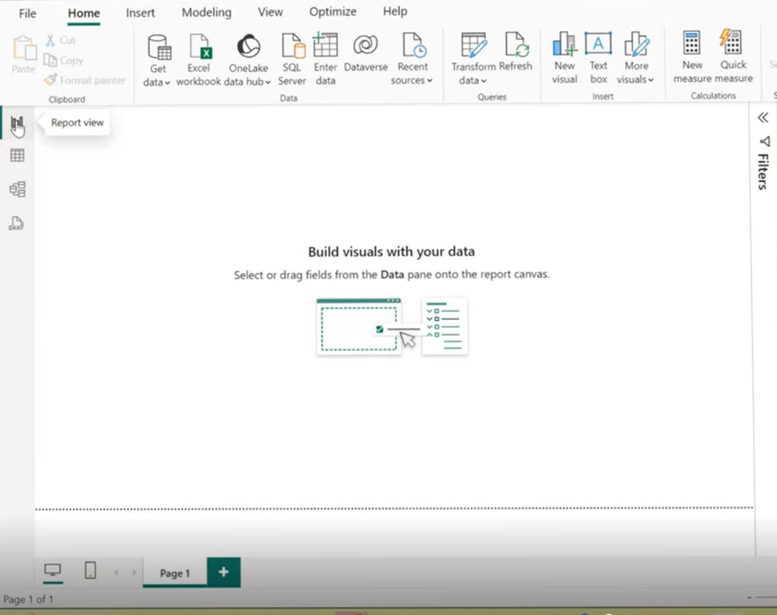

**2) Table View:**

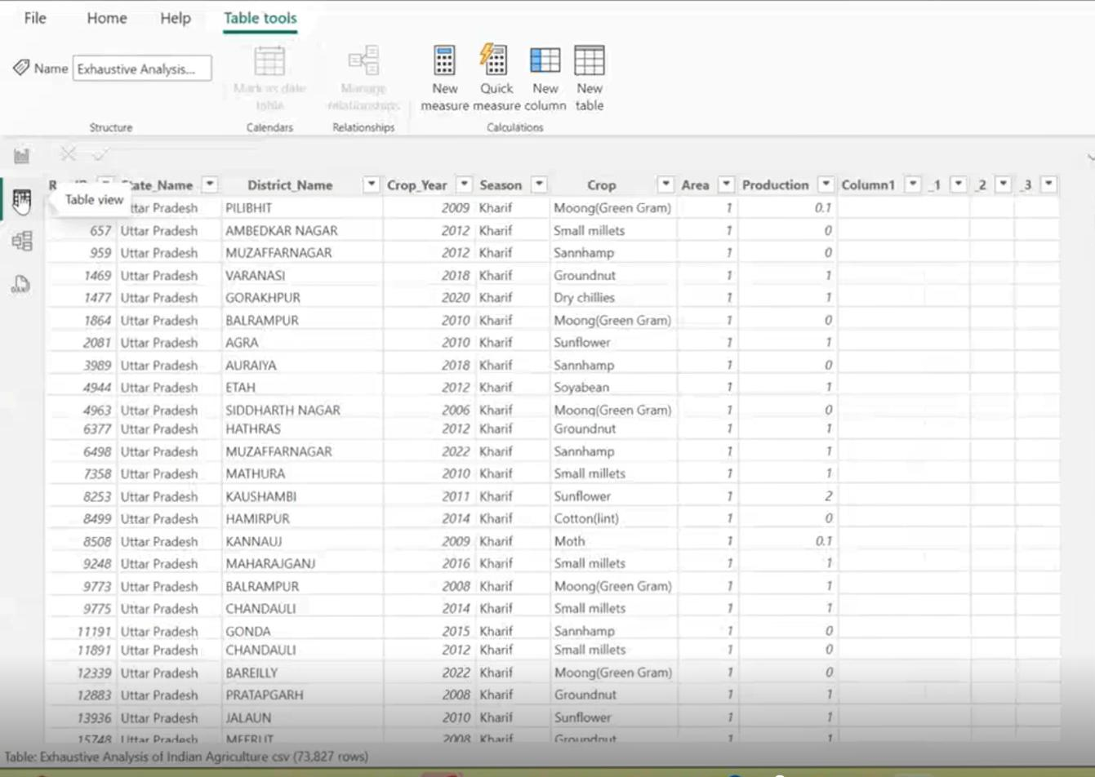**Table view helps you inspect, explore, and understand data in your Power BI Desktop model.**

**3)Model View:**

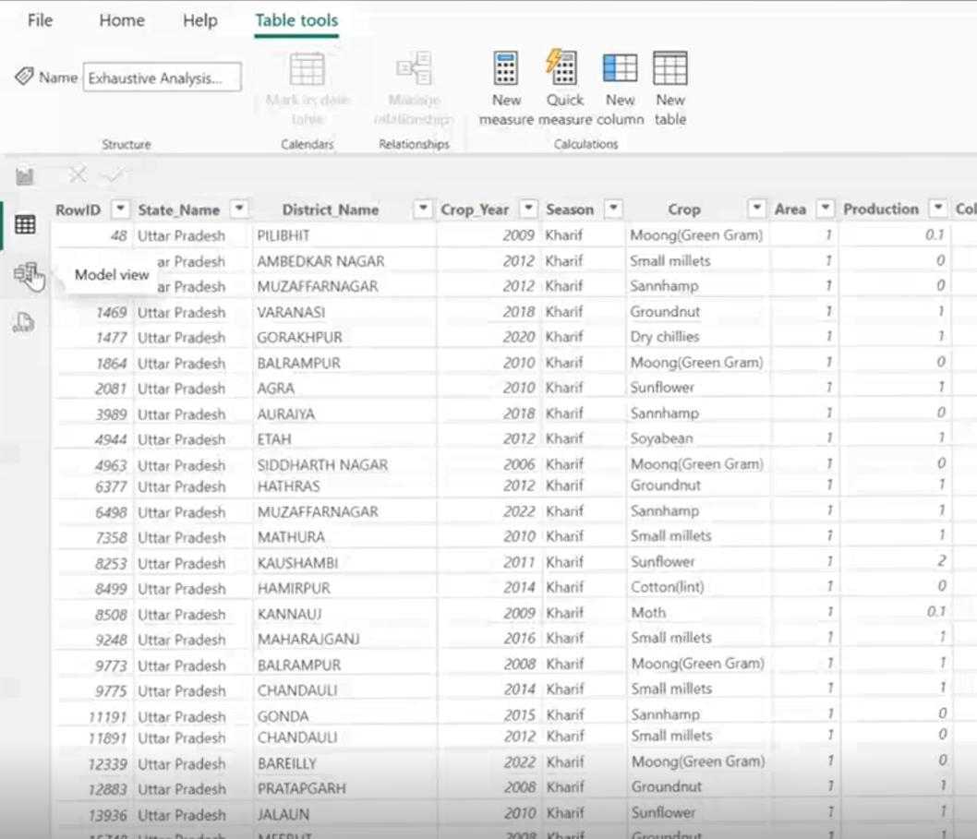**The Model view in Power BI Desktop lets you create diagrams of your model, which can help you work with complex data models.**

**Removing Columns in Power Bi:**

**There are two ways to remove columns in Power BI. As in renaming a column,You can right-click the header, which will present a menu with the option to Remove. You can also click on the column, click on the Home tab and then Click Remove Columns.**

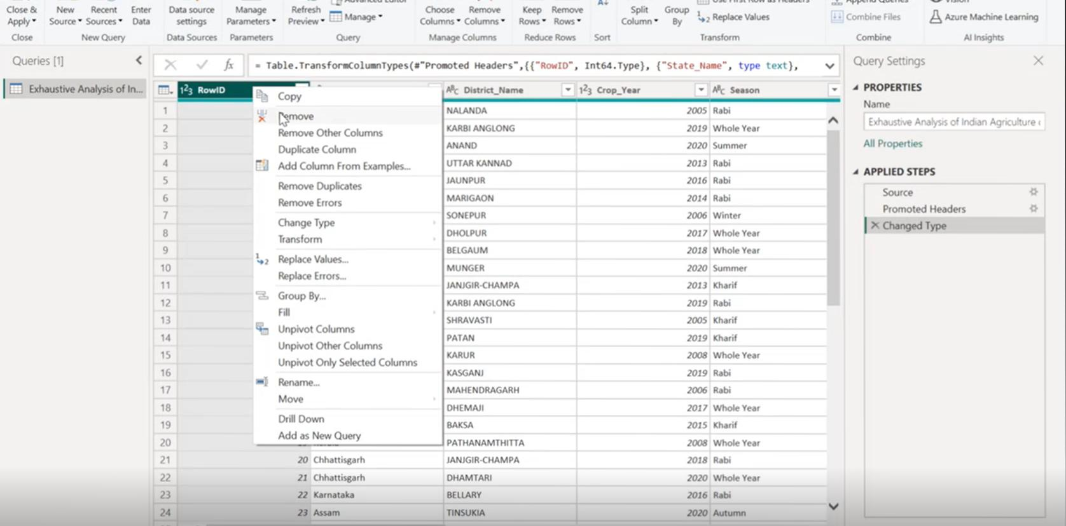

**Checking empty or Null values in data:**

**To check whether there any null value present in the given data,we simply click on the ‘column quality’ button and select the particular column in which we have to check.We can also eliminate the null values.**

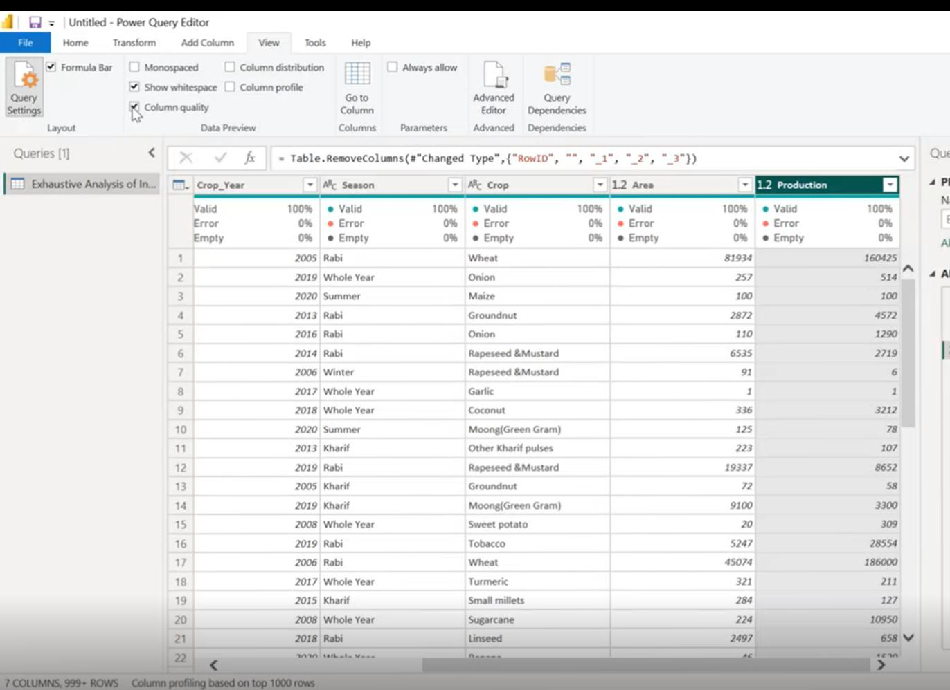

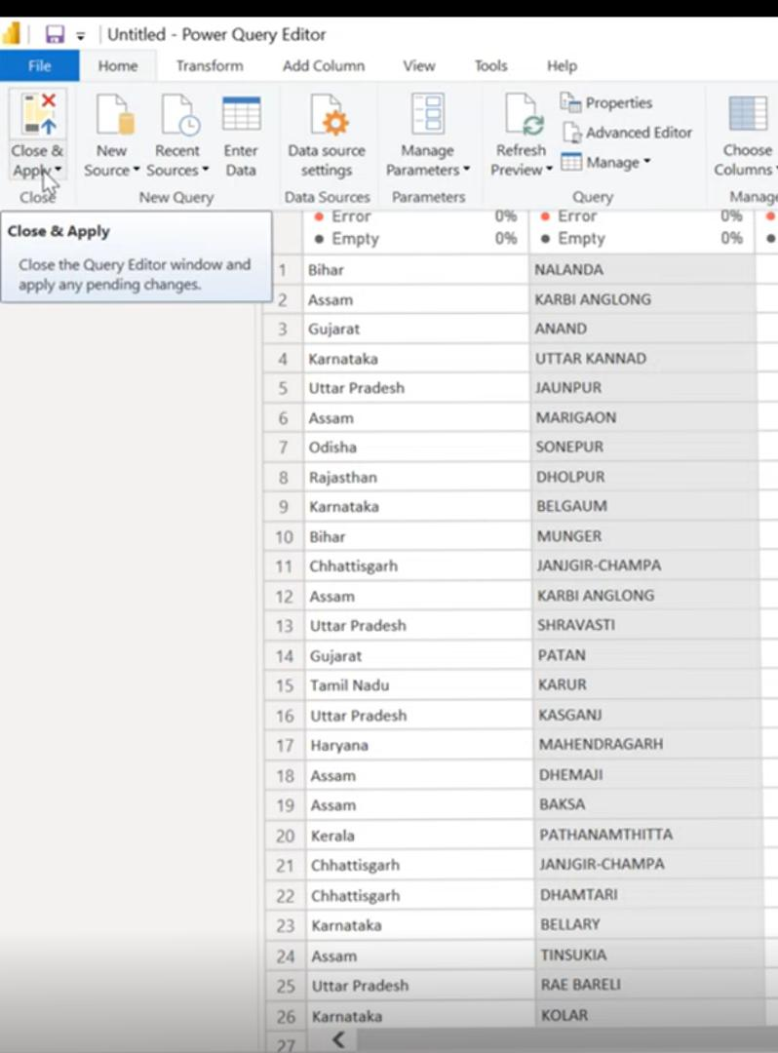**Saving the Data Ready for Analysis:**

**If we want to save the changes made in Power Bi,we would simply click on ‘Close and Apply’ button.**

**How to use Close & Apply ?**

**1)Make the desired changes to the query**

**2)Select Close & Apply from the File menu in the Power Query Editor**